Name of person writing press release | Insert date
Name of internal approver | Insert date
Name of external approval | Insert date
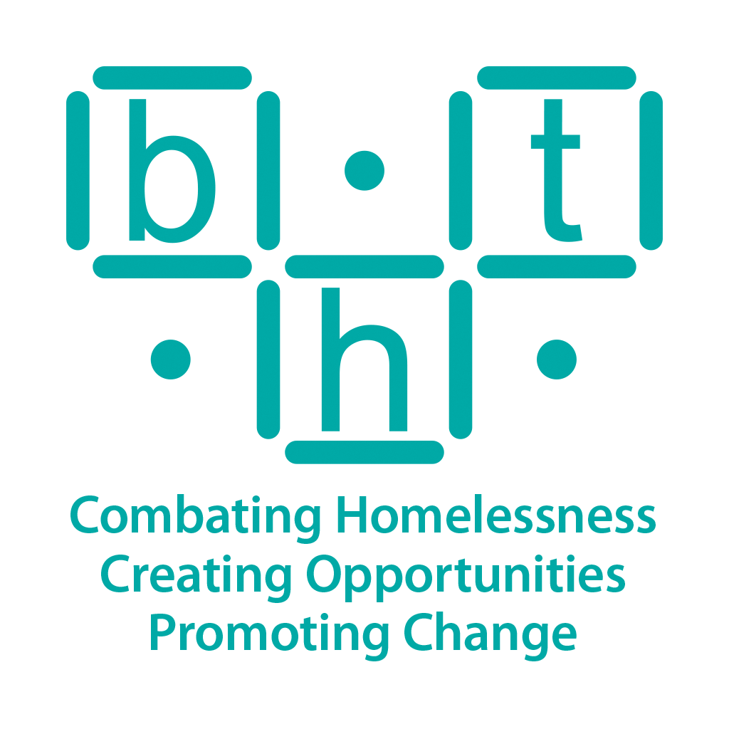
In aid of

[Location and type of business/school] to hold [type of event] for Brighton Housing Trust
[Place image here - ideally with BHT logo visible)

[Insert your name/group name] from [insert location] is holding a [insert type of event] on [insert date] to help raise funds for Brighton Housing Trust (BHT), which supports rough sleepers and vulnerably housed people across Sussex.

The event invites [locals/friends/family/customers] to enjoy a fun-filled day including [insert example activities/agenda]. With help from supporters, the [insert group/business/school name] is hoping to raise [insert amount] through [insert raffle/ticket sales etc.].

BHT provides services for those that are rough sleeping, vulnerably housed, have substance addictions, mental health issues or those that need advice to prevent them from becoming homeless.

Lauren Ellis, Fundraising Manager at BHT says: “We are very grateful that [insert school/business name] is holding such a fantastic event to help us fund our First Base Day Centre. It’s going to be a great [night/day]. Money raised from the event will enable us to provide food, hot showers, clean and dry clothes along with essential advice for rough sleepers in our city.” [or insert suggested quote]
- Ends -
PHOTO NOTES:
Photo 1 (L-R): [Insert name(s) of people in the above image from left to right, where it was taken and what they’re doing]

NOTES TO EDITORS:

First Base offers a range of services to support people who are sleeping rough or insecurely housed in Brighton and Hove, including food, showers, clean and dry clothes, and support to get off the streets. First Base also provides opportunities for work experience and learning. In partnership with other agencies, a range of services are provided for our clients including dentistry, podiatry, nursing interventions, mental health advice and support, and accommodation and relocation services. For more information see www.bht.org.uk/services/first-base-day-centre/

For more press information or opportunities please contact:

Nicki Morgan – Marketing and Comms Officer
Tel: 01273 645431
Email: nicki.morgan@bht.org.uk
Jo Berry – Head of PR and Marketing
Tel: 01273 645497
Email: jo.berry@bht.org.uk

